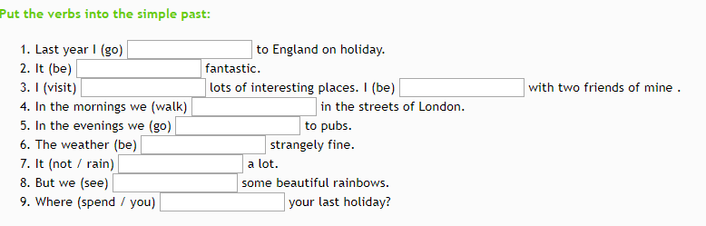

2. Put he verbs in simple past.

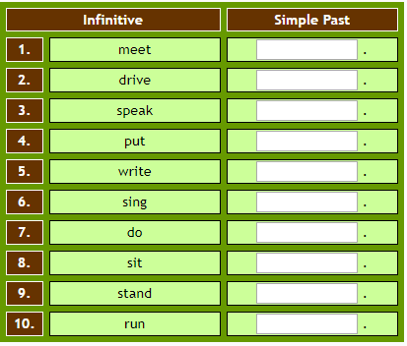

3. 